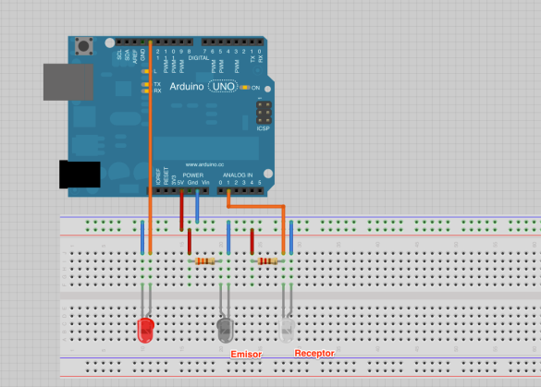

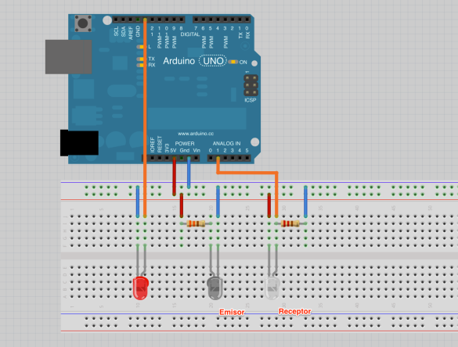

const int analogPin = A1;

const int OutPin = 13;

int sensorValue = 0;

void setup() {

Serial.begin(9600);

pinMode(OutPin,OUTPUT);

}

void loop() {

sensorValue = analogRead(analogPin);

if(sensorValue>900){

digitalWrite(OutPin,HIGH);

}

else

{

digitalWrite(OutPin,LOW);

}

Serial.print("sensor= ");

Serial.println(sensorValue);

delay(100);

}